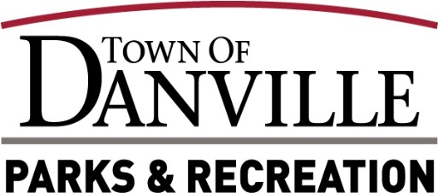

**Park Board Meeting Minutes**

**Wednesday 12/18/24**

**Attendance**

Park Board Members Present: David Glover, Jim Pearcy, Peter Trybula, Bill Sutton

Staff Present: Will Lacey, Eric Lobosky

Town Council Liaison:

Park Board Members & Staff Absent: Tim McRoberts

Public: Nan Martin

**Open Meeting**

David Glover called the Park Board meeting to order at 5:31pm.

**Pledge of Allegiance**

**Determination of Quorum**

A quorum is present.

**Consideration of Minutes**



A motion to accept the November 20, 2024, Park Board Meeting Minutes by David Glover, 2nd by Jim Pearcy. Motion passed 4-0.

**New Business**

1. J2 with Planning Results-Will Lacey noted that we met with J2 and reviewed the information gathered from the several public meetings held at Town Hall. The data stayed consistent from the previous meetings with Playscape leaning towards Option B and West Park leaning towards a mixture of Options A & B.
2. Winterland Update-Will Lacey noted that Winterland attendance has been down a bit from the start of the opening but is on the rise with Christmas just a week away.
3. 2025 Meeting Dates & Times-Will Lacey provided the list of Park Board meeting dates and times for 2025. The third Wednesday of each month and the start time of 5:30pm still works for everyone and a sheet has been presented for the board members to sign.
4. End of Year Report Details-Will Lacey stated that he is working on putting together all the “End of Year 2024” reports and asked if Park Board members had any special request for this report. David Glover asked about the percentage of Females vs Males that have a DAC membership. Will Lacey replied that currently the DAC memberships consist of 35% Female and 65% Males. No other special report requests were made at this time.

**Old Business**

1. Rec Update: Home School programs, Signing concert contracts for 2025 this week.
2. DAC Update: Locker room remodel started and would like to tour it with board members after meeting.
3. GFAC Update: Job openings and memberships will be available online starting January 1st, 2025
4. Trail Update: Just received a couple of trail path map options to review, still waiting on numbers for each option.
5. Hope Tree: Base is formed, drainage installed, electric ran, just waiting on sculpture from artist.
6. Jim Pearcy- A special THANK YOU from everyone on the park board, park staff and the community in which you served. Jim has served on the Park Board since 2013.

**Reports**

1. YTD Financial Report- Profit & Loss statements have been reviewed by Park Board with no questions. Will Lacey noted that we are finishing the year out with some minor upgrades and replacements with the little funds remaining.

**Public Comment:**

None

**Adjournment**

A motion was placed on the floor for adjournment by Jim Pearcy, 2nd by David Glover. Motion passes 4-0.

After no further business, meeting was adjourned at 5:48pm

The next board meeting will be 5:30pm on Wednesday, January 15th, 2025, located at 49 N. Wayne St., Danville, IN 46122

|  |  |  |  |
| --- | --- | --- | --- |
| **TITLE** | **NAME** | **SIGNATURE** | **DATE** |
|  |  |  |  |