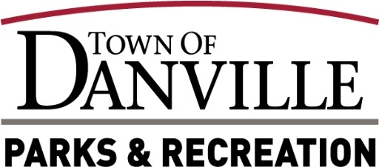

**Park Board Meeting Minutes**

**Wednesday 6/18/25**

**Attendance**

Park Board Members Present: Bill Sutton, Dani Smith, Peter Trybula, Mike Corbitt

Staff Present: Will Lacey, Eric Lobosky, Madison Henderson

Town Council Liaison: Greg Irby

Park Board Members & Staff Absent: David Glover

Public:

**Call Meeting to Order**

Bill Sutton called the Park Board meeting to order at 5:31pm.

**Pledge of Allegiance**

**Determination of Quorum**

A quorum is present.

**Consideration of Minutes**



A motion to accept May 21, 2025, Park Board Meeting Minutes by Mike Corbitt, 2nd by Peter Trybula. Motion passed 4-0.

**New Business**

1. Playscape Design-Will Lacey stated that he will be going in front of the next Town Council Meeting on July 2nd to request funding for the new playscape design.
2. Picnic Table Install-Will Lacey stated that we have been switching out old and damaged picnic table at Shelter 2 and Amphitheater. Will Lacey noted Shelter 1 is going to be a little more difficult due to getting them across the creek, but we will be working on that.
3. Helton Courts- Will Lacey stated we are working on replacing the water line along with repairing some of the overhead lights for the courts. Will Lacey mentioned it will be messy down there for a bit but will look great and have better function once completed.
4. Bollard Install-Will Lacey stated the bollards in Ellis Park have had some major abuse over the years and need fixed and/or replace. Will Lacey noted that we will be working on getting those updated and repairing those this summer.
5. Naming Rights-Will Lacey stated that Brent Pope reached out about naming Field 2 after Brent Taylor. Will Lacey conveyed to Brent Pope that we are leery to do that considering the future construction in that area and the condition of that field in which Pope understands. Bill Sutton stated that after discussion, the board feels like now is not the time, but maybe in the future.

**Old Business**

1. Recreation Update: First Summer concert at the amphitheater is this Friday with a U2 Tribute band. A sinkhole popped up on the trail next to the amphitheater and should have it stabilized and ready for the concert. The Summer Park Program started with averaging around 65 kids.
2. Danville Athletic Club: Waiting on some signage for restrooms, but up and running.
3. Gill Family Aquatic Center Update: Its going well, memberships are up from last year. Started swimming lessons.
4. Interurban Trail Update: Had a meeting with some questions on several areas that need surveyed and further studies to get better number of construction costs. May have some support from surrounding businesses and will continue to build those relationships.

**Financials**

1. YTD Financial Report- Profit & Loss statements have been reviewed by the Park Board with no questions.

**Public Comment:**

None

**Motion to Adjourn**

A motion was placed on the floor for adjournment by Dani Smith, 2nd by Mike Corbitt. Motion passes 4-0.

After no further business, the meeting was adjourned at 5:53pm

The next board meeting will be 5:30pm on Wednesday, July 16th, 2025, located at 49 N. Wayne St., Danville, IN 46122

|  |  |  |  |
| --- | --- | --- | --- |
| **TITLE** | **NAME** | **SIGNATURE** | **DATE** |
|  |  |  |  |