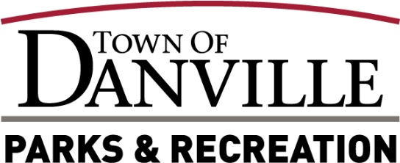
2025 Park Board Elections
All board meetings will be held in the Town Council room at 49 North Wayne Street, Danville, IN unless otherwise noted. Elections are held on an annual basis and voted on by Park Board Members. Four Park Board Members are appointed by the Town Council and one Park Board Member by the Danville Community School Board.

Town Council Appointed _____________________________ President
Town Council Appointed ________________________________ Vice President
Town Council Appointed ___________________________________ Secretary
Town Council Appointed___________________________________ Member
Town Council Appointed___________________________________ Member

See January 2025 minutes for voting numbers.

Park Board Approval Signatures
- _______________________________________________ Date __________________
- _______________________________________________ Date __________________
- _______________________________________________ Date __________________
- _______________________________________________ Date __________________
- _______________________________________________ Date __________________

